**Installation Steps**

**Visit : https://angular.io/**

**Install nodejs**

Visit : https://nodejs.org/en/

**Download and Install**

**Check node version**

**E:\>node -v**

v14.15.1

**npm gets installed by default with nodejs**

**E:\npm**

6.14.8

**Install angular**

**npm install -g @angular/cli**

To check Angular version

E:\> ng --version

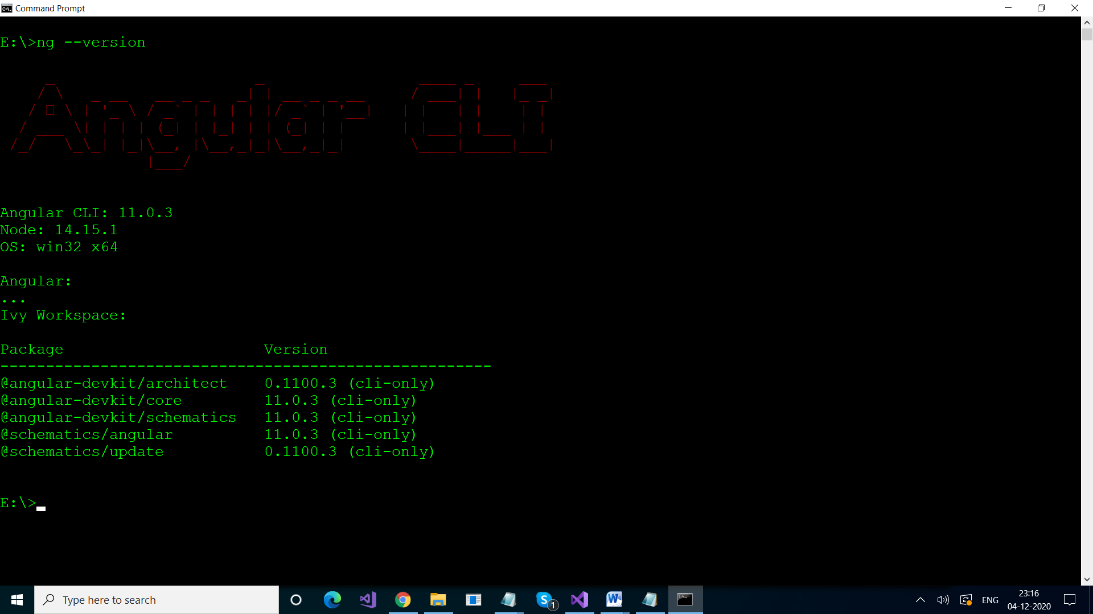

npm uninstall -g @angular-cli  
npm install -g @angular/cli@latest

**Create First Application**

**E:\>ng new my-app**

-----------------------------------------

**Editor : Visual Studio Code**

Install Visual Studio Code

Visit :

https://code.visualstudio.com/download

**Download and Install**